### Guest Lecture Report on "Matrices and Straight Lines"

**Date:** 3rd December 2024  
**Resource Person:** Sri L. Yasoda Krishna, Lecturer in Mathematics, RSRKRR College, Bobbili  
**Topic:** Matrices and Straight Lines  
**Venue:** Government Degree College, G.L. Puram  
**Organized by:** Department of Mathematics

The **Department of Mathematics**, Government Degree College, G.L. Puram, successfully organized a **Guest Lecture** on the topic **"Matrices and Straight Lines"** for the **First Year B.Sc. (Hons) Computer Science students** on **3rd December 2024**.

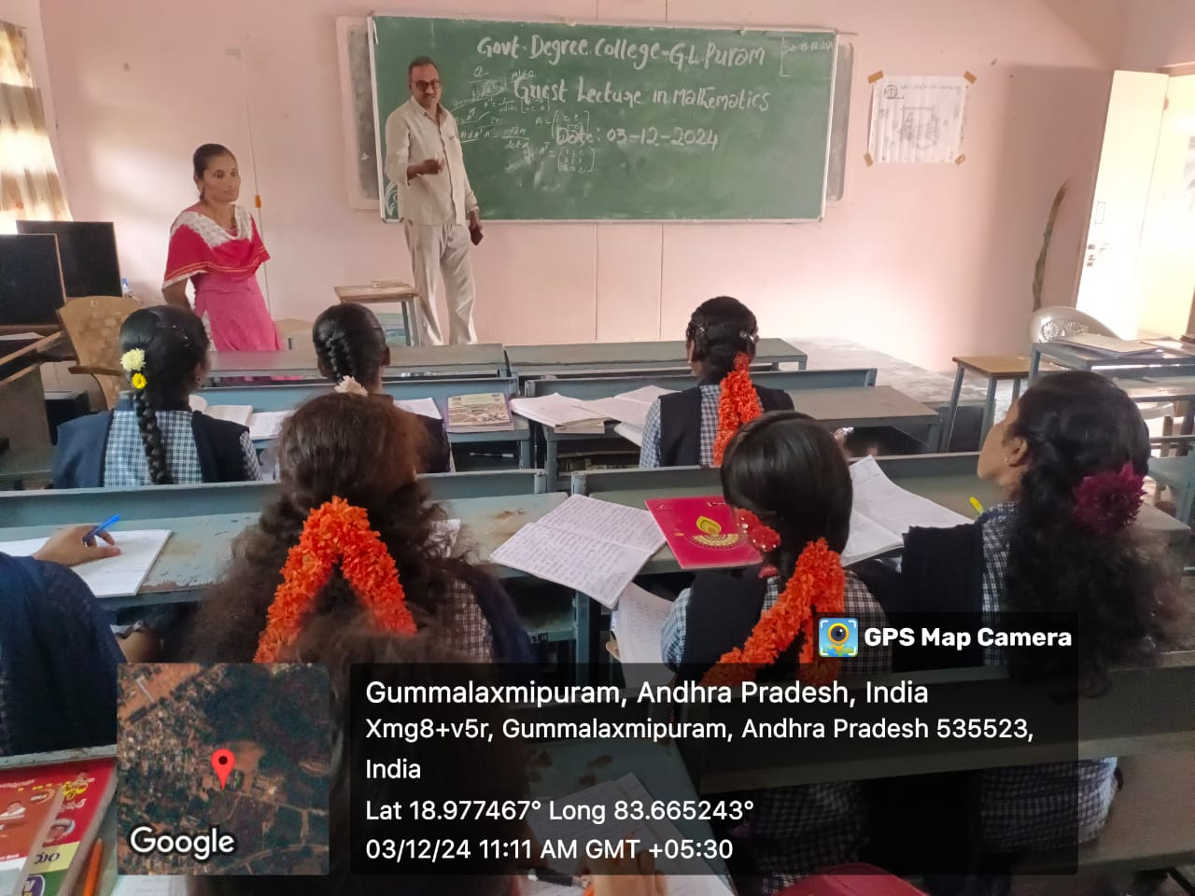

The session began with **Smt. G. Tulasi**, Lecturer in Mathematics, warmly introducing the guest speaker, **Sri L. Yasoda Krishna**, an eminent Lecturer in Mathematics from **RSRKRR College, Bobbili**.

The session was aimed at enhancing the students' conceptual understanding and application skills in the areas of matrices and coordinate geometry, which are crucial foundations for computer science and related fields.

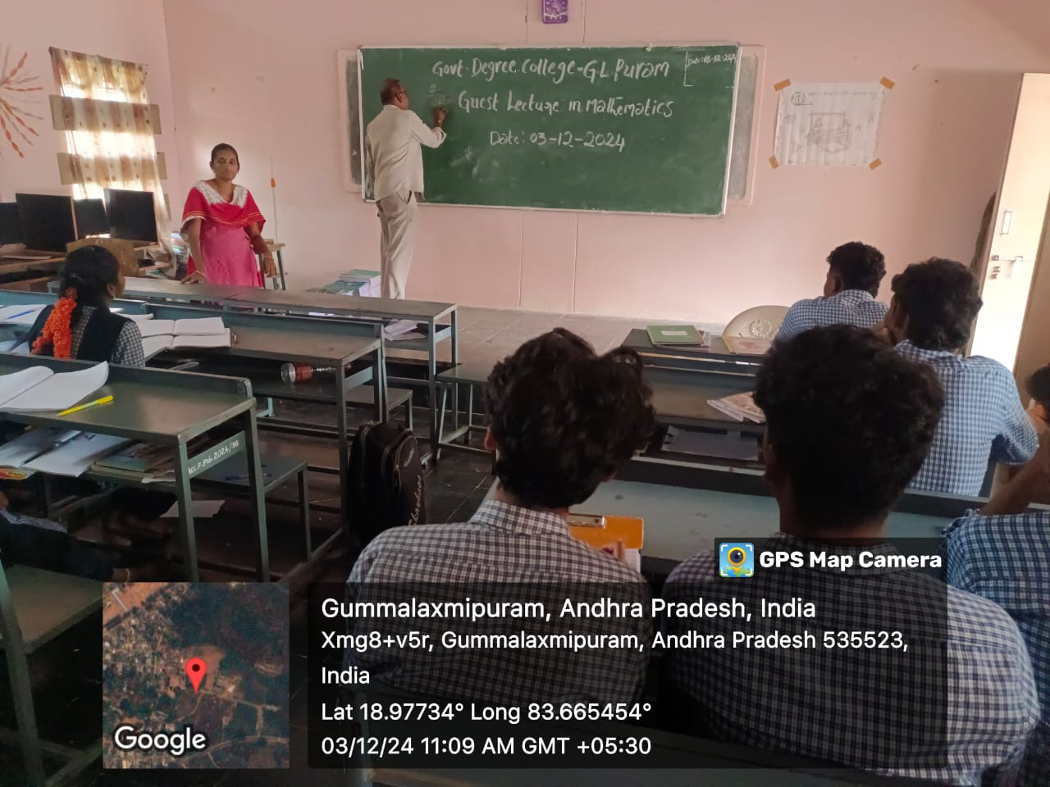

A total of **20 students** attended the lecture. The resource person, **Sri L. Yasoda Krishna**, delivered an engaging and insightful session, explaining complex concepts in a simplified and structured manner. His dynamic presentation skills and clear explanations kept the students actively engaged throughout the lecture.

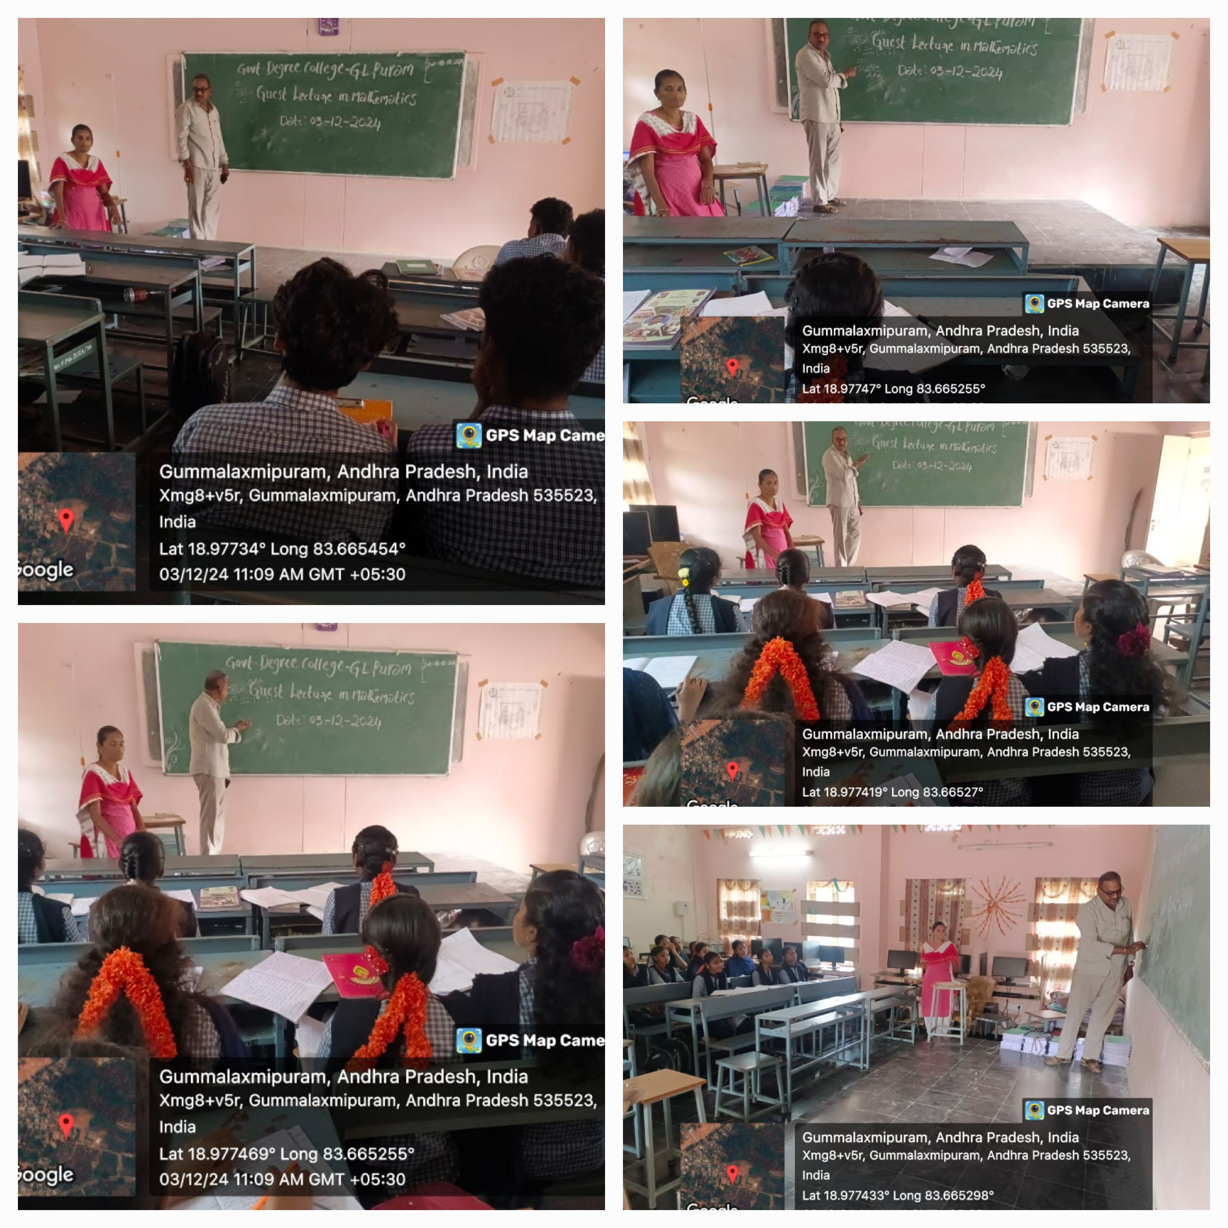

Students expressed great appreciation for the session, noting how it deepened their understanding of matrices operations, applications, and the significance of straight lines in analytic geometry. The interactive nature of the lecture encouraged students to ask questions and actively participate.

Overall, the event was highly beneficial, motivating students to strengthen their mathematical skills essential for their academic and professional growth.